**Leader Overview**



**Volume Overview**

**Navigate Hardship**

*Life is hard, even for believers. We all know it or discover it soon enough. Life tests our patience, our hope, and our sense of God’s presence. But we are not left hopeless in our challenges. God’s presence is more certain than even our hardships. Still, there are times in life that we need to be reminded that He is present. It’s in hardships that we learn to recognize it. We also learn to depend on God, to wait, and to look forward to His rescue.*

**Session Overview**

**Wait Patiently**

*In this* **Live** *session, preschoolers will discover the story of two sisters who called for Jesus to come when their brother got very sick. The three siblings were close friends of Jesus. While the sisters were waiting for Jesus, their brother died. Preschoolers will explore the truth that Jesus wept with the sisters just as He is sad with us when we’re heartbroken. They will learn to turn to God when they face hard things and to trust Him while they wait for Him to answer their prayers.*

**Bible Lesson**

Lazarus’s Family Deals with His Death

[John 11:1–7](https://ref.ly/logosref/Bible.Jn11.1-7), [20–45](https://ref.ly/logosref/Bible.Jn11.20-45)

**Faith Fact**

I can trust God while I’m waiting.

**Faith Verse**

[Psalm 34:19](https://ref.ly/logosref/Bible.Ps34.19) (NLT)

The righteous person faces many troubles, but the Lord comes to the rescue each time.

**Preparing for the Session**

**Leader Preparation Time: 20–25 Minutes**

|  |
| --- |
| ***You Will Need***  ***Preservice Activities***  *• Toys*  *• Box*  *• Wrapping paper or newspapers*  *• Small gift*  *• Apple slices, cut into ½-inch slices, one or more per kid*  *• Grapes, four or more per kid*  *• Toothpicks, two per kid*  *• Small plates or napkins, one per kid*  ***Large Group***  *• Bible*  *• Worship songs (Song suggestions: “Boom” Lyric Video by Go Kids Worship; “For All My Days” Lyric Video by Gateway Kids Worship; “Jump” Lyric Video by Go Kids Music)*  *• For groups not using a phone or tablet only, add:*  *• Projector or TV*  *• Laptop*  *•* ***Faith Fact Sound*** *video (bell ringing)*  *•* ***Faith Fact Slide***  *•* ***Faith Verse Slide***  *•* ***Faith Verse Video***  *•* ***Bible Lesson Video A***  *•* ***Bible Lesson Video B***  ***Small Group***  *• Soft ball or small stuffed animal, one per group*  *•* ***Small Group Activity Page****, one per kid*  *• Pencils or pens, one per kid*  *• Crayons or markers*  *• Smartphone with timer*  *To access session content and videos from a computer, visit:* [***BibleEngagementProject.com/downloads***](https://bibleengagementproject.com/downloads) |
| ***Getting Ready***  ***Preservice Activities***  *• Set out toys and snacks.*  *• Wrap a small gift with layers of wrapping paper, preferably one layer per kid.*  *• Prep the fruit by cutting the apples into slices and pulling the grapes off the cluster. If you cut apples before the session, put lemon juice on them to keep them from turning brown too quickly.*  ***Large Group***  *• Download videos and slides if needed.*  *• Select worship song(s) and have them ready to play.*  ***Small Group***  *• Print copies of the* ***Small Group Activity Page****, one per kid*  ***First time leading* Live *for Preschool? Check out the*** [**Facilitator Guide**](https://0b769b0ed3569ef9d18b-f88d8272f61086866d50d048b43ef630.ssl.cf2.rackcdn.com/sites/biblengagementproject/Listen_Facilitator_Guide.pdf)**.** |

**Preservice Activities**

*See what’s needed at the beginning of the session.*

**Bible Story Warm-Up**

How many of you like to celebrate your birthday or Christmas? *(Group response)* What is one of the reasons you like those holidays? *(Allow responses.)* One reason is definitely because we like to get presents. How many of you like to get presents? *(Group response)* Me, too!

Sometimes it’s hard to wait for our birthday or Christmas to come around. It seems like they take forever to get here. We have to wait 365 days between one birthday and the next. It’s like that for Christmas too. Waiting that many days can be hard.

• *Hold up the wrapped gift.*

I have this present. Would you like to help unwrap it? *(Group response)* Great! We’ll pass it around and let each one of you will help to unwrap it. Now, you can’t just tear into it like you might your own gift. You have to take off the paper one layer at a time. The person who takes off the last layer gets to keep whatever is inside of this gift. Okay, are you ready to start and see what’s inside? *(Group response).* Here we go!

• *Have kids sit in a circle so the gift can be passed easily.*

• *Make sure kids are being gentle with removing the paper and not just tearing it to shreds.*

Was it hard to wait your turn?

Were you excited to tear off the wrapping paper when it was your turn?

What is one thing that you have a hard time waiting for?

You all did so well in our activity today. Waiting can be hard, but sometimes if we wait patiently, something good comes from it. Today, we’ll hear a Bible story about a family who had to wait on Jesus, and it was very hard for them. I’m so excited for you to learn what Jesus did.

**Snack**

**Fruit Car**

Today’s snack is delicious and fun to make. Can you think of a place you might be every day where you have to wait? *(Allow responses.)* Those are some great answers. I am thinking about riding in the car. When you get in the car, you know you will have to wait before you arrive at the place you’re going. Today, we’ll make cars from apple slices and grapes.

• *Hand out snack pieces.*

• *Insert toothpicks horizontally into both ends of the apple slice.*

• *Slide grapes onto the toothpicks to make wheels.*

• *Show kids how to make their cars and assist as needed.*

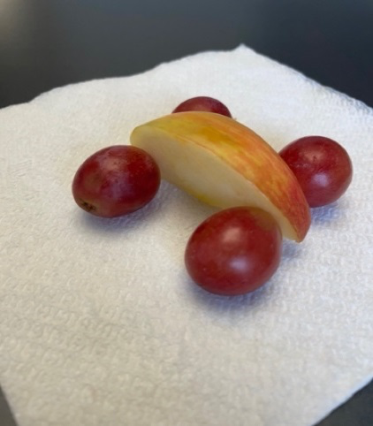

What are some places where you have to wait in the car? *(Allow responses.)* Those are good ideas. Sometimes we have short waits like at stoplights and stop signs. Sometimes our wait is longer like at the drive-through of a restaurant or on a car trip. What do you do to pass the time when you have to wait in the car? *(Allow responses.)* When you have made your car, you can eat it.

**Free Play**

*Any extra time can be spent playing with toys.*

**Transition**

*A few minutes before service begins have kids make their way to the large group area and sit in their designated areas.*

**Large Group**

**25 Minutes**

*See what’s needed at the beginning of the session.*

**Introduction**

Hi, kids! My name is _______. On the count of three, I want you to say your name. 1, 2, 3. *(Group response)* I’m so glad that each of you is here today! We’ll have a great time exploring God’s Word together. *(Hold up the Bible.)*

Today, we’ll learn about waiting. So let’s just practice waiting. On the count of three, I want you to say, “Waiting.” Ready? *(slowly)* 1 *(slowly)* 2 *(pause as long as possible here)* 3. *(Group response)* I’m so relieved we got to three, but you had to wait, didn’t you? *(Group response)*

**Faith Fact**

Our Bible story will show us how it can be hard to wait sometimes, but we can always trust God while we wait. That’s our Faith Fact today: **I can trust God while I’m waiting.**

• *Show the* ***Faith Fact Slide.***

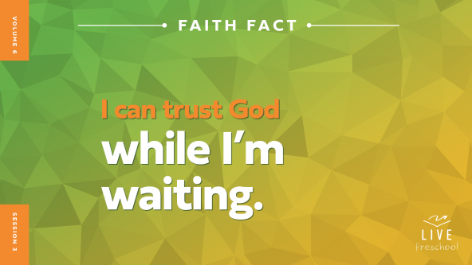

Let’s say our Faith Fact as slowly as we can. **I can trust God while I’m waiting.** You’re so good at talking slowly. Now, turn the speed knob on your mouth to fast *(demonstrate pretending to rotate knobs on side of mouth).* Let’s say it as quickly as we can. **I can trust God while I’m waiting.**

*(Keep talking fast.)* Oh my goodness, my ears could barely understand what you were saying because it was so fast. Let’s turn our mouths back to normal speed *(demonstrate rotating knobs again).*

**Bible Time**

That’s much better. We are back to normal. Now, it’s time for a visit from a very special friend. Her name starts with a *L* sound. Who knows who that might be? *(Group response)* Yes, it’s Lizzy.

• *Play* ***Bible Lesson Video A****.*

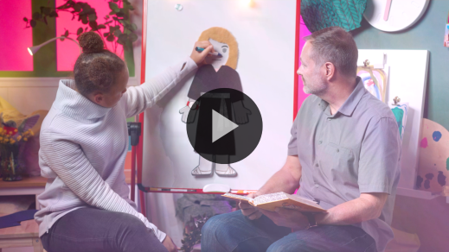

That’s a tough question. I think we need some time to think about that one. Wave your hand at me if you’re glad Grandpa will wait for our answer. *(Group response)* While we wait, let’s worship God!

**Worship**

*Worship* is a big word that means we show God how much we love Him and how important He is to us. We can use our whole bodies to worship God, including our feet, our hands, our mind, and our voice. I want you to listen for each one of those because I’ll give you instructions for each one. Are you listening? *(Group response)*

**Praise**

Who wants to thank God for being with us while we wait? March in place with your feet. *(Group response)*

Are you glad we can trust God? Wave your hands up high. *(Group response)*

Who can think about something amazing God has done? Put your hands on your head. *(Group response)*

**Sing**

Now, we get to use our voice to worship God. Let’s warm up our low singing voices. *(Group response)* Now, let’s warm up our high singing voices. *(Group response)* I think we’re ready to worship together.

• *Lead the kids in singing one or two songs. See song suggestions at the beginning of the session.*

**Prayer**

I love singing songs with you. I love worshipping God with you. Let’s talk to God and tell Him with our voice how great and wonderful He is to us.

|  |
| --- |
| *Dear God, thank You that You always love us and hear our prayers. Thank You that we can trust You all the time, even while we are waiting. Amen.* |

**Bible Time cont’d**

• *Start* ***Bible Lesson Video B*** *and pause on the image of the two choices.*

Grandpa and Lizzy should be back soon! Let’s think about the answer to Grandpa’s question. What will happen next? Let’s put on our thinking caps *(demonstrate)*. Did Jesus still come to see Mary and Martha? *(Point to the thumbs-up graphic on screen.)* Or did Jesus stay away since Lazarus had already died? *(Point to the thumbs-down graphic on screen.)* Ready? Show me your answer. Thumbs-up or thumbs-down?

• *Pause while kids respond.*

Let’s see what the correct answer is when we check back in with Lizzy and Grandpa.

• *Play* ***Bible Lesson Video B.***

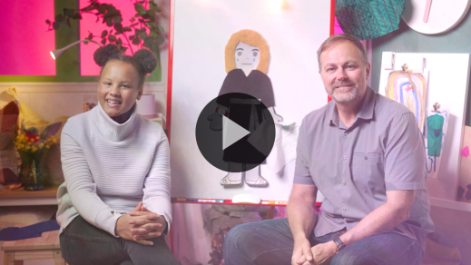

Wow! Did anything surprise you in that Bible story? *(Allow responses.)* It’s really interesting to hear that Jesus cried too. Jesus loves us all more than we can imagine. He even loves us more than our parents love us. Can you imagine that? *(Group response)*.

**Response Time**

*Play a worship song quietly.*

When we hear about Jesus’ great love and learn more about who He is, we should respond. Let’s respond to what we heard today. First, let’s pray.

• *Have the kids repeat phrases of the prayer after you.*

|  |
| --- |
| *Dear Jesus, we want to learn how to trust You while we wait. When we’re sad, we’ll turn to You. When we’re waiting, we’ll trust You. Amen.* |

**Faith Verse**

One of the best things we can do to help us trust God is to learn His Word. One way we do that is by learning our Faith Verse. Let’s say our Faith Verse and do the actions together.

[Psalm 34:19](https://ref.ly/logosref/Bible.Ps34.19) (NLT)

The righteous person faces many troubles, but the Lord comes to the rescue each time.

• *Show the* ***Faith Verse Video****.*

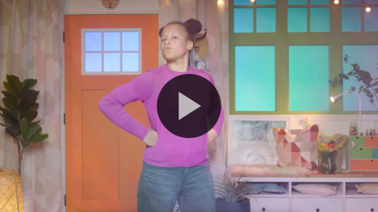

**Psalm** *(hands at waist, spread apart, palms up and out)*

**34:** *(hands together like a clap)*

**19** *(hands opened to “book”)*

**The righteous person** *(hands on hips with triumphant look on face)*

**faces many troubles,** *(fists up to chin with scared look on face)*

**but the Lord comes to the rescue** *(run in place)*

**each time.** *(jump once with each word)*

Wow! Great job, friends! Keep practicing our Faith Verse at home, and we’ll say it again when we’re together next time.

**Closing**

Well, did you have to wait too much today? *(Group response)* Good. Waiting can be hard, but we learned who we can trust when we’re waiting, didn’t we? *(Group response)*

• *Play the* ***Faith Fact Sound*** *video (bell ringing).*

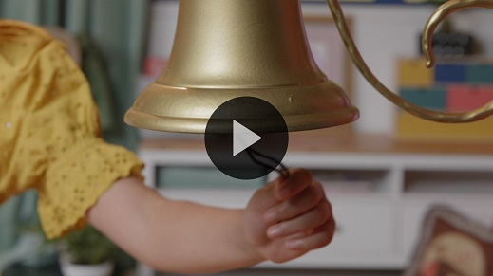

That sound means it’s time to practice our Faith Fact one more time: **I can trust God while I’m waiting**.

• *Show the* ***Faith Fact Slide.***



Let’s tap our wrist like we’re wearing a watch while we say our Faith Fact this time. **I can trust God while I’m waiting**. Now, let’s shout it with all of our faith-filled voices. **I can trust God while I’m waiting**.

**Dismissal to Small Groups**

That sounded amazing! Now, it’s time to head to our circles with our friends and do some more fun activities.

• *Dismiss the kids by groups.*

|  |
| --- |
| ***Leader Tip:*** *This can be done by assigning color teams or by age groups. Note that some young preschoolers may not know their age. Using a colored sticker, jersey, or wristband will help separate the kids and help identify their small groups.* |

**Small Group**

**25 Minutes**

*See supplies and prep instructions at beginning of session or in each activity below.*

|  |
| --- |
| ***Leader Tip:*** *Small groups can alternate to each circle, or all groups can do each activity at the same time. If you choose to alternate, you will need at least one leader per circle.* |

**Circle 1**

**Group Connection**

**Toss Across**

|  |
| --- |
| ***You Will Need***  *• Soft ball or small stuffed animal, one per group*  *No prep needed for this activity.* |

Who is ready to play a game? *(Group response)* Let’s play Toss Across. We’ll sit in a circle. One of you will start by gently tossing this ball across the circle to someone. When you catch the ball, share your name and your favorite part of our Bible story today. The rest of us will patiently wait our turn and listen to what everyone shares. When you’ve shared, pick a new friend and toss the ball to them. Are you ready? *(Group response)*

• *If you have more time, play a second round and have kids say the Faith Fact when they get the ball.*

That was amazing! You did a great job waiting for your turn to share. It was so fun hearing what your favorite parts of our Bible story were. Thanks for sharing!

**Circle 2**

**Activity Page Time**

**Stop, Wait, and Go**

|  |
| --- |
| ***You Will Need***  *•* ***Small Group Activity Page****, one per kid*  *• Red, yellow, and green crayons or markers*  *• Pencils or pens, one per kid*  ***Getting Ready***  *• Print copies of the* ***Small Group Activity Page****, one per kid.* |

We learned in our Bible story today that sometimes we have to wait. Waiting can be hard. There will be times when we have to wait on God. Let’s learn how we can do that.

• *Hand out the copies of the* ***Small Group Activity Page****, pencils, red, yellow, and green crayons****.***

What do you see on your Activity Page today? *(Group response)* Yes, it’s a stoplight. Beside it are three things we can do when we need God’s help. Let’s look at the top light on the stoplight. Does anyone know what it says? *(Group response)* It says, “Stop.” What color tells us to stop? *(Group response)* Red! First, we must remember to stop and pray. Go ahead and color the first light red. Then trace the word *Stop* on your paper.

• *Allow time for kids to complete this first part. Make sure kids know where to trace* Stop*.*

When Lazarus got sick, Martha and Mary wanted Jesus to come right away. When we face hard things, the first thing we need to do is stop and talk to God. We need to pray and ask for His help.

Great job so far! The middle light is about our Faith Fact. Can someone remind me what our Faith Fact is? *(Group response)* That’s right! **I can trust God while I’m waiting.** What color light reminds us to slow down and wait? *(Group response)* Yellow is correct. When we pray, if God doesn’t answer us right away, we need to remember to trust Him and wait. In our Bible story, Jesus didn’t come right away, so Martha and Mary had to wait for Him. Their brother got even sicker, and then he died. They were very sad while they waited. Color the middle light yellow and trace the word *Wait* as a reminder.

• *Allow time for kids to complete the second part, including tracing the word* Wait*.*

There’s one more light to color. Does anyone know what color it will be? *(Group response)* You got it! Green means go. Color that part of the stoplight green. Once we know God’s answer, we go with it! Trace the word *Go*.

• *Allow time for kids to complete this part, including tracing the word* Go*.*

Jesus got there at exactly the right time. Jesus was so sad that He cried at the grave of His friend. Then, Jesus helped Mary and Martha in an amazing way! What happened at the end of our story? *(Allow responses.)* You’re right! Lazarus came back to life. Martha and Mary had to trust God a lot while they waited for Jesus. The same is true for us. If God has said He would answer our prayer in a certain way, no matter how long we have to wait, we can always trust God.

**Circle 3**

**Feet-to-Floor Game Time**

**Red Light, Green Light**

|  |
| --- |
| *No prep is needed for this activity.* |

Who remembers our Faith Fact? *(Group response)* Let’s say it together. **I can trust God while I’m waiting.** When we stop to pray and ask God to help us, we have to wait until He answers. Sometimes God answers quickly, and sometimes He takes a while. Let’s play a fun game to help us practice listening closely to someone and waiting for direction.

Who has played Red Light, Green Light before? *(Group response)* When I say, “Red light,” you must stop, freeze, and clasp your hands like you’re praying. If you don’t listen carefully when I say, “Red light,” you have to sit down while everyone else plays the next turn. When I say, “Green light,” you get to start moving around. Who is ready to play? *(Group response)*

• *Remind kids who move after you say, “Red light,” to be seated until the next turn.*

• *Let kids take turns being the leader.*

• *Play until you’re out of time.*

• *During the activity, interrupt and practice the Faith Fact:* **I can trust God while I’m waiting.**

• *Play the* ***Faith Fact Sound*** *video****.*** *Review the Faith Fact even if you can’t play the sound.*



You did great! I loved watching you all have fun and work on waiting until it was time to go. Great job!

**Circle 4**

**Hands-On Learning**

**Perfect Timing Challenge**

|  |
| --- |
| ***You Will Need***  *• Smartphone with timer*  *No prep is needed for this activity.* |

Today we learned about trusting God’s perfect timing. Waiting for God’s answer to our problem can be really hard! We never quite know when He will answer our prayers. So today, we’ll play a game to practice waiting. We’ll pretend that it will take one minute for God to answer us. So, I’ll start my timer. When you think it’s been one minute, I want you to come and line up by me. We’ll see who gets the closest to waiting for exactly one minute.

• *Start the timer and keep timing until every kid has come to stand by you.*

• *Pay attention to who guesses the closest to one minute.*

You did a great job practicing waiting! *(name of winner)* waited the closest to one minute. Was it easy or hard to wait? *(Allow responses.)* Waiting can be hard, but God wants us to keep waiting until He answers us. It’s impossible for us to know the exact time when something will happen or even what should happen sometimes. We can trust that God’s timing is perfect. Here’s what that looks like. This time when you wait, you don’t have to think about how long you need to wait. I will start the timer, and I’ll tell you when it’s been one minute. All you need to do is trust me while you wait.

• *Time for one minute.*

Was it easier to play when you didn’t have to guess how long to wait? *(Group response)* That’s how it should be when we trust God while we wait. He will answer us when we wait on Him. In God, we have trust and confidence that He will answer us in His time. He always knows what is best for us!

**Dismissal**

• *Play the* ***Faith Fact Sound*** *video (bell ringing).*



• *Show the* ***Faith Fact Slide.***



I’m sad that our time today is almost over. Before we go, can we say our Faith Fact together one last time? **I can trust God while I’m waiting.** Fantastic! I’ve had a great time learning more about God from His Word with you. See you next time!

• *Send home the* ***Small Group******Activity Page*** *with each kid.*

• *Remind parents that there are* ***Family Devotions*** *available on the app to do with their kid.*

• *Tell everyone the date and time for the next session.*